**Dialed Number string config:**

**ICM1 (No Survey)**

Set Routing client to “ATT_NIC_7”

Set Customer to “None”

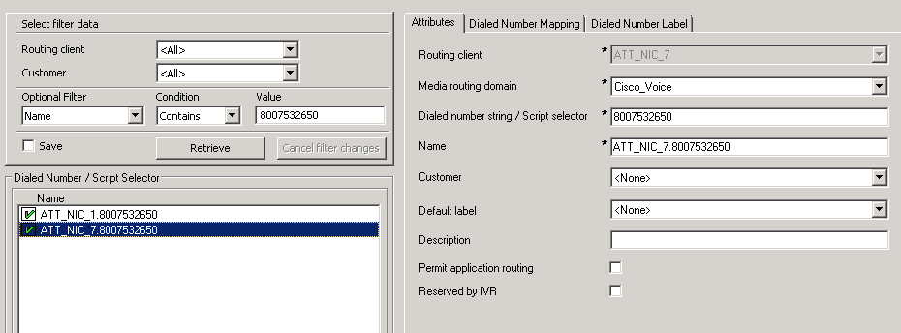

Set DNM (second Tab) to “SIP_TransRouteToCVPFromATTNIC”

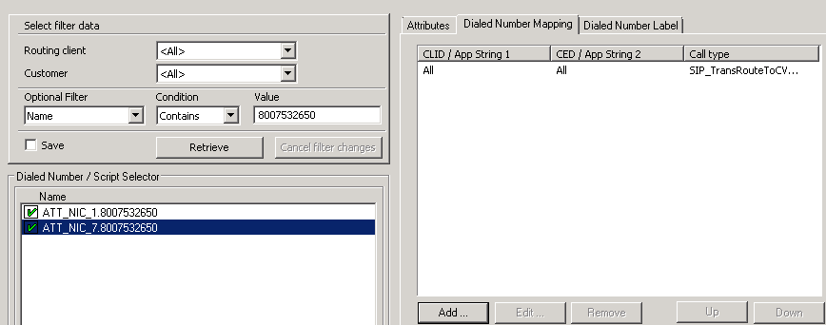

**ICM 2 (No Survey)**

Set Routing client to “i2i_UHG”

Set Customer to “UHGA1”

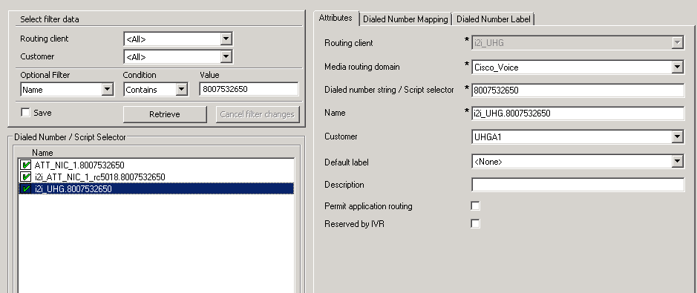

Set DNM to “i2i_Master”

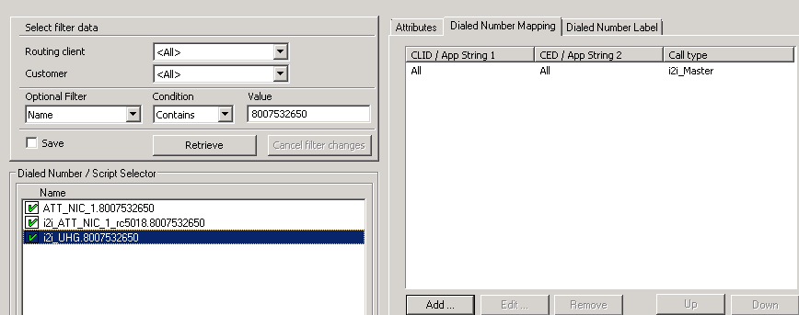

**ICM1 (With Survey)**

Set Routing client to “ATT_NIC_7”

Set Customer to “None”

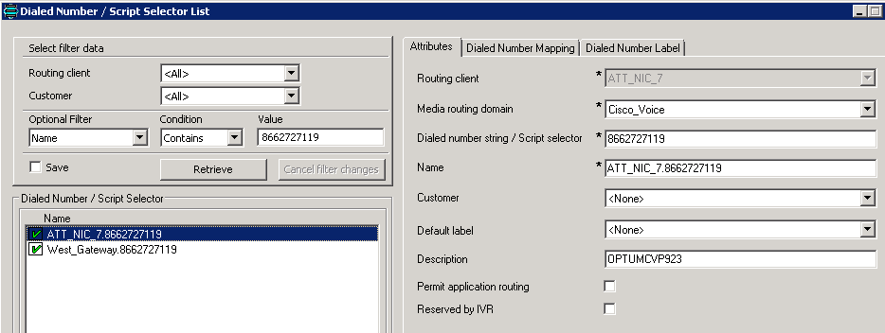

Set Routing Client to “West_Gateway”

Set Customer to “None”

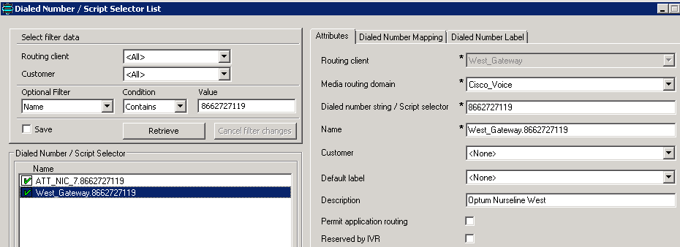

Set DNM to “CVP_Master_Routing”

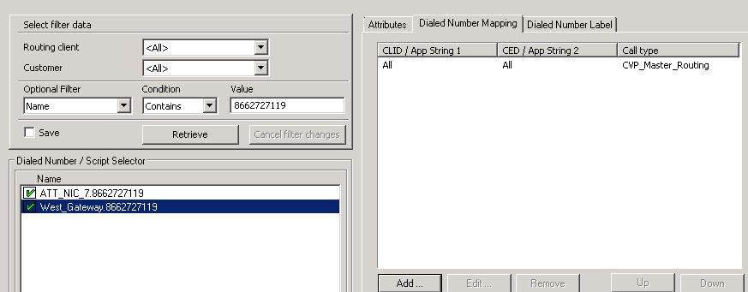

**ICM2 (With Survey)**

Set Routing client to “i2i_UHG”

Set Customer to “UHGA1”

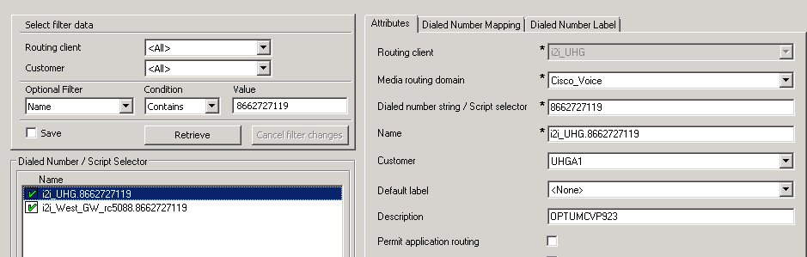

Set Routing client to “i2i_West_GW_rc5088”

Set Customer to UHGA1

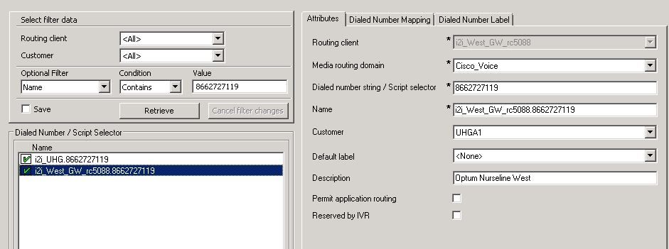

Set DNM to “i2i_Master”

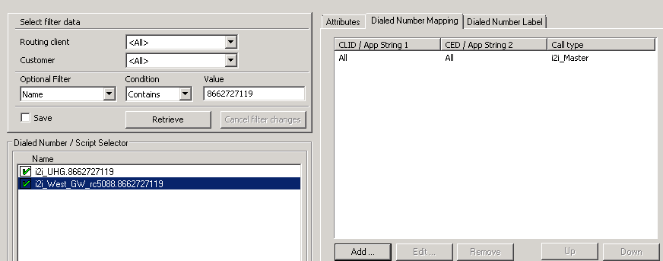

**Adjunct Route VDN’s**

ICM1

Set Routing client to “i2i_Node05_rc5085”

Set Customer to “UHG”

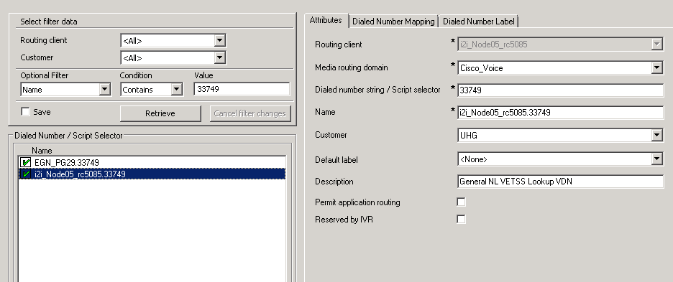

Set DNM to “OPT_VCC_VDN_LookUP”

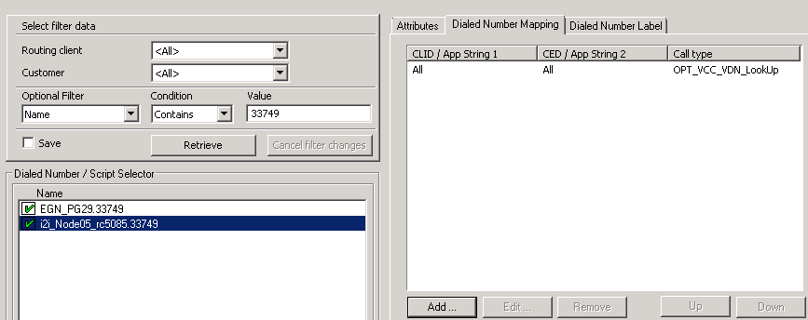

**Adjunct Route VDN’s**

ICM2

Set Routing client to “EGN_PG29”

Set Customer to “None”

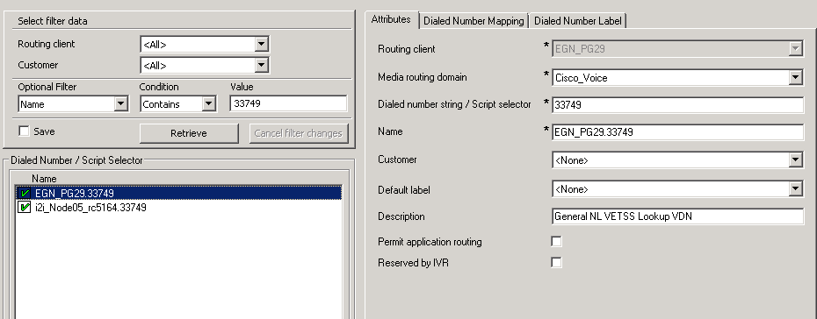

Set DNM to i2i_Master_To_ICM1

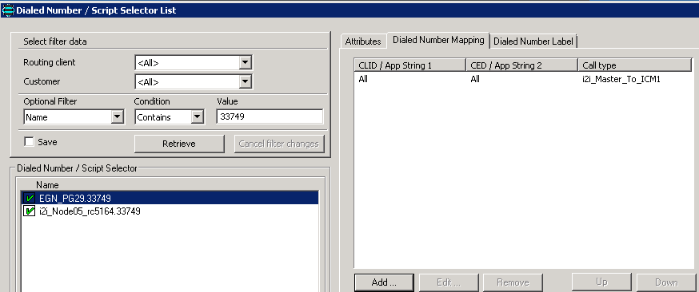

Set Routing Client to “i2i_Node05_rc5164”

Set Customer to “UHGA1”

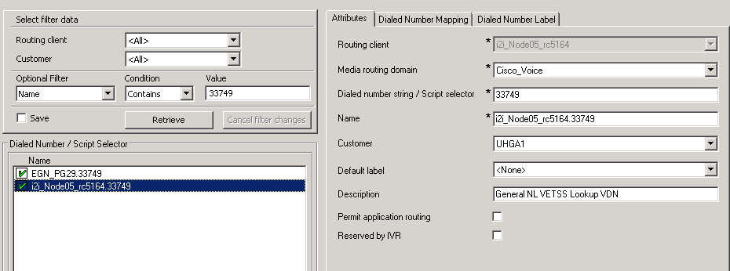

Set DNM to “i2i_Master”

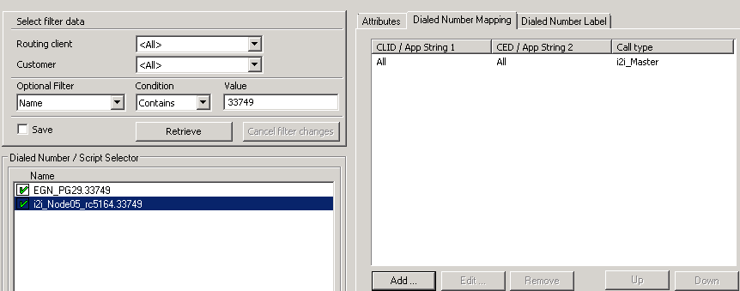

**How to build a Skill in ICM 2**

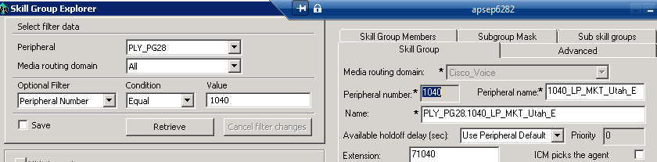

Skill group section on the right, enter new skill number 1040 in Peripheral number field

Tab to Peripheral name and name the skill as per your intake, S****_LP_MKT_Utah_E

Tab to Name field and this will fill in automatically

Extension for PG28 needs to have a 7 in front of the skill number, this can be different for each PG, check an existing PG skill to find the extension information you need

Hit save!

**How to build a Service in ICM 2**

Peripheral should be set to the node you’re working in.

Optional Filter should be set to Peripheral Number.

Enter New VDN into Value field and hit enter or retrieve, if unassigned hit add service at the bottom

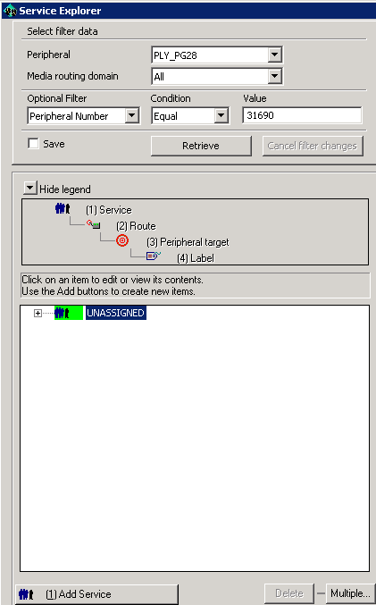

Add the new vdn to Peripheral number field

Peripheral name needs service and the skill as below

Tab to name field and it will fill in automatically

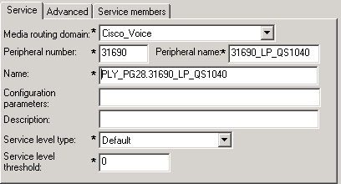

Click Advanced Tab

Fill in the extension field with the vdn information

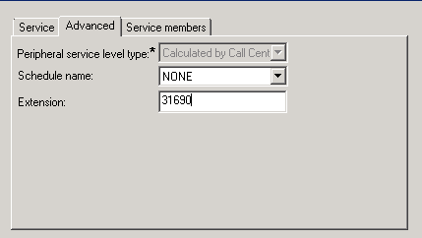

Click Service members Tab

Hit add

Select the Skill

Hit ok

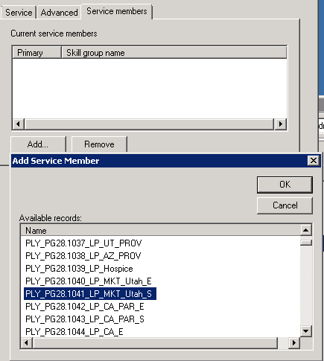

Head back to the service tab

Add Route and enter

Add Peripheral Target and enter

Add Label and fill in as below

